`

EQUAL OPPORTUNITIES POLICY

It is the policy of SciQuip Ltd to treat all employees and job applicants fairly and equally regardless of their sex, sexual orientation, marital status, race, colour, nationality, ethnic or national origin, religion, age, disability or union membership status.
Furthermore, SciQuip Ltd will ensure that no requirement or condition will be imposed without justification, which could disadvantage individuals purely on any of the above grounds.
The policy applies to recruitment and selection, terms and conditions of employment including pay, promotion, training, transfer and every other aspect of employment.
SciQuip Ltd will regularly review its procedures and selection criteria to ensure that individuals are selected, promoted and otherwise treated according to their relevant individual abilities and merits.
SciQuip Ltd is committed to the implementation of this policy and to a programme of action to ensure that the policy is, and continues to be, fully effective. The overall responsibility for the policy lies with Matt Brooksbank, General Manager. However, all staff are required to comply with the policy and to act in accordance with its objectives so as to remove any barriers to equal opportunity.
Any act of discrimination by employees or any failure to comply with the terms of the policy will result in disciplinary action.
SciQuip Ltd undertakes regular audits of its suppliers to ensure that they also comply with its Equal Opportunities Policy.

Signed By

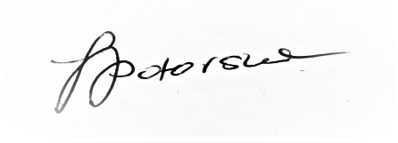
Justyna Potorska
Head of Operations

Initial Release Date: February 2011

